West 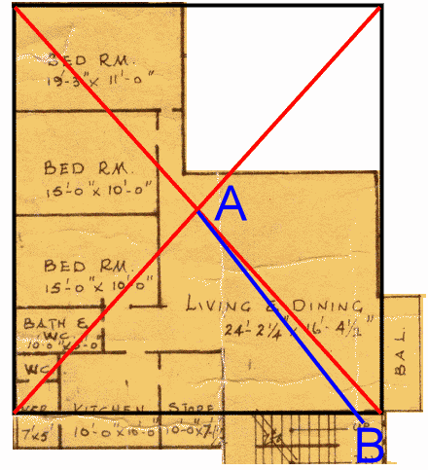
East

B is the exact point of my main door (north east)
My bed room is next to the bath room

